

Need Energy Smart System

DevShop

Develper: Prince



DEDICATION

ACKNOWLEDGEMENT

ABSTRACT

TABLE OF CONTENTS

LIST OF FIGURES

LIST OF TABLES

1.0 CHAPTER ONE: INTRODUCTORY CHAPTER

1.1 INTRODUCTION

This is a project based on the Development of a Gas Smart Meter Systme for Home use and use by SME

1.2 BACKGROUND

Need Energy is a renewable energy start up that seeks to develop new technologies which, are improve effecient use of energy as it is one of the world’s needs. Currently looking into African Demography especially Zimbabwe they has been a steady increase into LP gas usage. Due to the steady rise in LP gas market in Zimbabwe and Africa as a whole there is a need to developer smart technologies which will increease efficient usage of LP gas usage. LP gas has its associated dangers like risk to gas poisoning and explosion this has made needenergy to develop a smart gas meter system for home use.

1.3 AIM

The project is aimed at developing an smart gas meter system for home use. Which increase efficent use of LP gas in house holds.

1.4 OBJECTIVES

- To Design a self regulating smart gas system
- To Design Temperture sensing system
- To Design LP gas Leak Sensing system

1.5 SCOPE

The System is an IOT based project which focuses on the design of an embeded system which control the different components. The design will need ti adhere to the ISO standards on Gas Cylnder.

1.6 JUSTIFICATION

2.0 CHAPTER TWO: INVESTIGATION

2.1 INTRODUCTION

In this section of project we will focus on Research necesssary for the design of the system that is we will look at suitable control system, different valves used of cylinder, gas canister sizes, and different sensing devices used in system.

2.1 GAS CANISTER

House hold gas canister have variable sizes and they varry from 3kg gas canisters to 47kg gas canisters. The following table shows us a detailed table of different gas house hold canisters with their dimensions

Cylinder | Type/Size | Height | Diameter
Propane: | 3.9kg | 340mm | 240mm
Propane: | 5kg Patio Gas | 314mm | 306mm
Propane: | 6kg | 495mm | 256mm
Propane: | 9kg | 460mm | 315mm
Propane: | 11kg | 560mm | 310mm
Propane: | 12kg | 560mm | 310mm
Propane: | 13kg Patio Gas | 580mm | 315mm
Propane: | 13kg | 580mm | 315mm
Propane: | 18kg | 810mm | 315mm
Propane: | 19kg | 810mm | 315mm
Propane: | 47kg | 1290mm | 375mm

Table 2.0 Propane Gas Canister Sizes ( gascagedirect 2017)

In Africa especially in Zimbawe we usually have the following gas canister used in house holds and these are as follows, 5kg, 9kg, 12kg, 14kg, 19Kg, 48Kg according to Total (nd) LPG in Cylinder.

As part of the need energy business model which focuse on developing these different technologies for energy we adoptated the size range followed by Total. The Diagram in the next page shows Images of Gas Cylinders of different sizes.

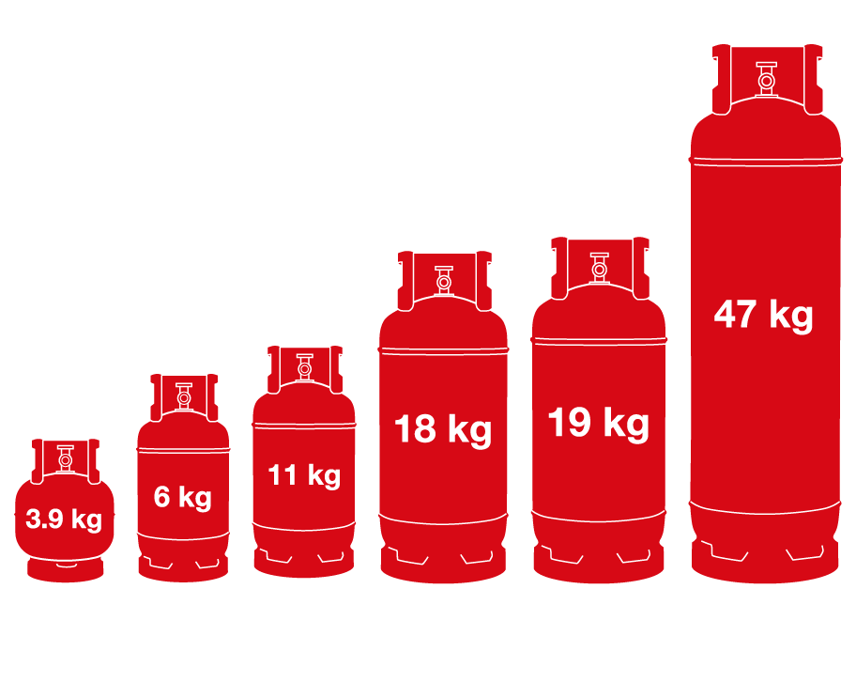
Fig 2.0: Gas Canister Range

2.2 SOLENOID GAS VALVES

Valves are mechanical devices that controls the flow and pressure with a system or process. They are essential components of piping system that conveys liquids, gases, vapors, slurries etc. Different types of valves are available: gate, globe, plug, ball, butterfly, check, diaphragm, pinchm pressure relief, control valves etc. Each of these types has a number of models, each with different features and functional capabilites. Some valves are self-operated while others manually or with an actuator or pneumatic or hydraulic operated. According to Wermac (nd ) Introduction to Valves- Only basics.

2.2.1 SOLENOID GAS FUNCTIONALITY

A solenoid valve is an elctrochemical controlled valve, The valve features a solenoid, which is an electric coil with a movable ferromagnetic core in its center. This core is called the plunger . In the closed state this plunger shuts off a small orifice. An Induced magnetic field is created due to small electrical current, exerting a force to the plunger which pulls the plunger towatds the center of coil so that the orifice opens. This is the basic principle that is used for opening and closing valves.(solenoid valves).

Solenoid valves are used to close, distribute or mix the flow gas or liquid on a pipe. The specific purpose of a solenoid valve is expressed by its curcuit function. A 2/2 way valve has two ports(inlet and outlet) and two positions(open or close). A 3/2 way valves have three ports and two position and can therefore switch between two circuits. 3/2 way valves can have different functionssuch as normally closed, normally open, diverting or universal. More ports or combinations of valves in a single construction are possible. The circuits function can be expressed in a symbol. Solenoid Valves can be categorizied into different groups of operations which will be coverved in the following sub-sections.

2.2.1.1 DIRECTED OPERATED

Direct Operated(direct acting) solenoid valves have the most simple working principle. The medium flows through a small orifice which can be closed off by a plunger with a rubber gasket on the bottom. A small spring holds the plunger down to close the valve. The plunger is made of a ferromagnetic material. An electric coil is positioned around the plunger. As soon as the coil is electrical energized, a magnetic field is created which pulls the plunger up towards the centre of the coil. This opens the orifice so that the medium can flow through. This is called a Normally Closed (NC) valve. A Normally Open (NO) valve works the opposite way: it has a different construction so that the orifice is open when the solenoid is not powered. When the solenoid is actuated, the orifice will be closed. The maximum operating pressure and the flow rate are directly related to the orifice diameter and the magnetic force of the solenoid valve. This principle is therefore used for relatively small flow rates. Direct operated solenoid valves require no minimum operating pressure or pressure difference, so they can be used from 0 bar up to the maximum allowable pressure. The displayed solenoid valve is a direct operated, normally closed 2/2 way valve. According to Tameson (nl) Solenoid valve types.

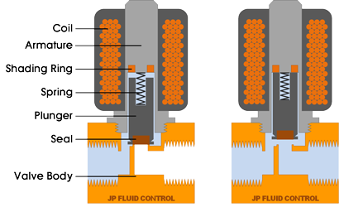
Fig 2.1: Direct Operated

2.2.1.2 INDIRECT OPERATED (SERVO OR PILOT OPERATED)

Indirect operated (also called servo operated, or pilot operated) use the differential pressure of the medium over the valve ports to open and close. Usually these valves need a minimum pressure differential of around 0.5 bar. The inlet and outlet are separated by a rubber membrane, also called diaphragm. The membrane has a small hole so that the medium can flow to the upper compartment. The pressure and supporting spring above the membrane will ensure that the valve remains closed. The chamber above the membrane is connected by a small channel to the low pressure port. This connection is blocked in the closed position by a solenoid. The diameter of this "pilot" orifice is larger than the diameter of the hole in the membrane. When the solenoid is energized, the pilot orifice is opened, which causes the pressure above the membrane to drop. Because of the pressure difference on both sides of the membrane, the membrane will be lifted and the medium can flow from inlet port to outlet port. The extra pressure chamber above the membrane acts like an amplifier, so with a small solenoid still a large flow rate can be controlled. Indirect solenoid valves can be used only for one flow direction. Indirect operated solenoid valves are used in applications with a sufficient pressure differential and a high desired flow rate, such as for example irrigation systems, showers or car wash systems. Indirect valves are also known as servo controlled valves.

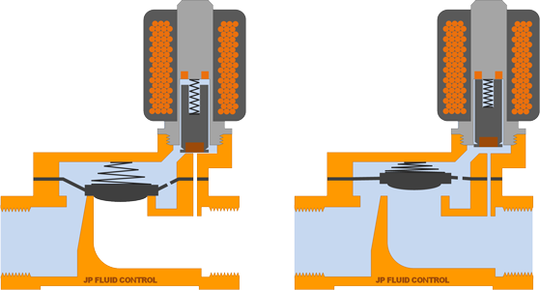
Fig 2.1: Inderct Operated

2.2.1.3 SEMI-DIRECT OPERATED

Semi-direct operated solenoid valves combine the properties of direct and indirect valves. This allows them to work from zero bar, but still they can handle a high flow rate. They look somewhat like indirect valves and also feature a movable membrane with a small orifice and pressure chambers on both sides. The difference is that the solenoid plunger is directly connected to the membrane. When the plunger is lifted, it directly lifts the membrane to open the valve. At the same time, a second orifice is opened by the plunger that has a slightly larger diameter than the first orifice in the membrane. This causes the pressure in the chamber above the membrane to drop. As a result, the membrane is lifted not only by the plunger, but also by the pressure difference. This combination results in a valve that operates from zero bar, and can control relatively large flow rates. Often, semi-direct operated valves have more powerful coils than indirect operated valves. Semi-direct operated valves are sometimes called assisted-lift solenoid valves.
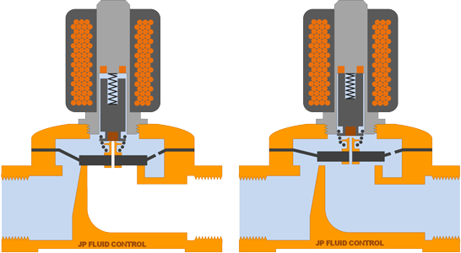
Fig 2.3: Semi-Indirect Operated

2.2.1.4 DIRECT OPERATED 3/2 WAY SOLENOID VALVES

A 3/2 way solenoid valve has three ports and two switching states. In each switching state, two of the three ports are connected. By activating the solenoid, the valve switches state and a different connection between the valve ports is established. The drawing below shows a direct operated 3/2 way valve. In the de-energized state, the medium can flow between from the port on the right side to the top port. In the energized state, the medium can flow from the left port to the right port. This is a called a normally closed 3/2-way valve.

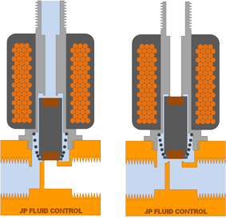
Fig 2.4: Direct Operated 3/2 Way Solenoid Valves

2.3 MICRO CONTROLLERS

A micro controller is a self conatined system with peripherals, memory and a processor that can be used as an embedded system. Most programmable microcontrollers that are used today are embedded in other consumer products pr mavjinery including phones, peripherals, automobiles and household appliances for computer systems. Due to that another name for a micro controller is embedded controller. Some embedded systems are more sophisticated, while others have minimal requirements for memory and programming lengt and low software complexity. Input and output devices include solenoids, LCD displays, relays, switches and sensors for data like humidity, temperature or light level, amongst others.

As a result there is a different types of micro controllers categorized using several different types of parameters such as RAM, Bits, Flash Memory, Input/Output Lines, package type, suppy voltage and speed. But under normal circumstances we normally use Bit size for classifying and choosing the suitable type of micro controller. We therefore have 8 bit Microcontroller, 16 bit Digital Signal Controllers, 16 bit General Purpose Microcontrollers and 32 bit Microcontrollers. According Futerelectronics (nd) What is a Microcontroller?

Controller | Flash (KB) | SRAM (Byte) | EEPROM (Byte) | I/O-Pins | A/D (Channels) | Interfaces
AT90C8534 | 8 | 288 | 512 | 7 | 8 | UART, SPI
AT90LS2323 | 2 | 128 | 128 | 3 |  | UART, SPI
AT90LS2343 | 2 | 160 | 128 | 5 |  | UART, SPI
AT90S1200 | 1 | 64 |  | 15 |  | UART, SPI
AT90LS8535 | 8 | 512 | 512 | 32 | 8 | UART, SPI
AT90S2313 | 2 | 160 | 128 | 15 |  | UART, SPI
ATmega128 | 128 | 4096 | 4096 | 53 | 8 | JTAG, SPI, IIC
ATmega162 | 16 | 1024 | 512 | 35 |  | JTAG, SPI
ATmega169 | 16 | 1024 | 512 | 53 | 8 | JTAG, SPI, IIC
ATmega16 | 16 | 1024 | 512 | 32 | 8 | JTAG, SPI, IIC
ATtiny11 | 1 |  | 64 | 5+1 In
ATtiny12 | 1 |  | 64 | 6 |  | SPI
ATtiny15L | 1 |  | 64 | 6 | 4 | SPI
ATtiny26 | 2 | 128 | 128 |  | 16 | SPI
ATtiny28L | 2 | 128 |  | 11+8 In
Table 2.3 Comparison of AVR 8-bit controllers (AVR, Atmega, Attiny).

Fig 2.5: Microcrontroller Layout

Basically Microcrontoller has two architecture which RISC and CISC and we are going to look at the different architecture.

2.3.1 RISC ARCHITECTURE

